Transaction Logic
# Source: Chatgpt (GPT-5-Mini) at [1/21/2026]
Transaction logic is the back-end brain of your payment system. It defines how you handle a payment from the moment a user clicks "Pay" to the moment your app marks it as "successful" or "failed". In a custom bank integration, you have to build this logic yourself.

🎯 Purpose of Transaction Logic
# Source: Chatgpt (GPT-5-Mini) at [1/21/2026]
To:
- Send payment requests to the bank’s API
- Track each transaction’s status
- Handle failures, timeouts, and retries
- Keep your database and UI in sync with real payment outcomes
- Manage receipts, refunds, and notifications

🧩 Core Tasks in Transaction Logic

1. Create a Payment Request
# Source: Chatgpt (GPT-5-Mini) at [1/21/2026]
- Generate a unique transaction/order ID
- Prepare data: amount, currency, customer info, callback URL, etc.
- Send request to the bank’s payment initiation endpoint
- Receive a payment URL or token (if redirection is required)
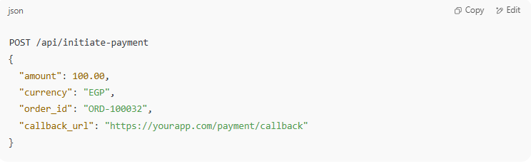

POST /api/initiate-payment
{
"amount": 100.00,
"currency": "EGP",
"order_id": "ORD-100032",
"callback_url": "https://yourapp.com/payment/callback"
}

2. Redirect the User (if needed)
# Source: Chatgpt (GPT-5-Mini) at [1/21/2026]
- If 3D Secure or OTP is involved, redirect the customer to the bank’s verification screen.
- After verification, they are redirected back to your system.

3. Listen for Callbacks (Webhooks)
# Source: Chatgpt (GPT-5-Mini) at [1/21/2026]
- The bank sends a server-to-server request to your callback URL with the payment result.
- You must validate the callback (e.g., with an HMAC hash or signature).
- Mark the transaction as "paid", "failed", or "pending".
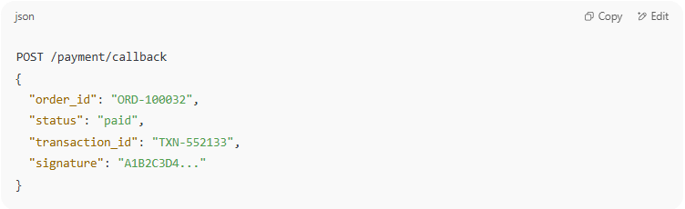

POST /payment/callback
{
"order_id": "ORD-100032",
"status": "paid",
"transaction_id": "TXN-552133",
"signature": "A1B2C3D4..."
}

4. Verify Transaction (Optional but Safe)
# Source: Chatgpt (GPT-5-Mini) at [1/21/2026]
- Even after receiving a callback, you can double-check with the bank’s API:
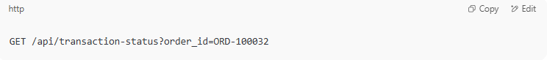
GET /api/transaction-status?order_id=ORD-100032

5. Handle Errors & Timeouts
# Source: Chatgpt (GPT-5-Mini) at [1/21/2026]
- If the bank API fails or times out, mark transaction as incomplete or retry later.
- Provide users with proper feedback (e.g., “We couldn’t confirm your payment. Please try again.”)

6. Update Database & Notify Systems
# Source: Chatgpt (GPT-5-Mini) at [1/21/2026]
- Update your order/payment table with:
  - Transaction ID
  - Status (success, failed, refunded)
  - Payment method
  - Timestamps
- Send email or push notifications if needed

📤 Other Functions You Might Include
# Source: Chatgpt (GPT-5-Mini) at [1/21/2026]
- Refund logic
- Partial or scheduled payments
- Installments or recurring billing
- Retry failed payments

🧠 Best Practices
# Source: Chatgpt (GPT-5-Mini) at [1/21/2026]
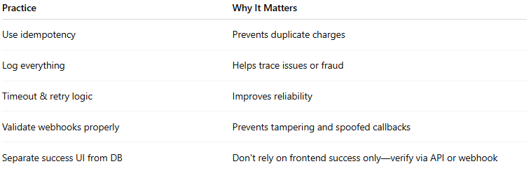

Practice | Why It Matters
Use idempotency | Prevents duplicate charges
Log everything | Helps trace issues or fraud
Timeout & retry logic | Improves reliability
Validate webhooks properly | Prevents tampering and spoofed callbacks
Separate success UI from DB | Don't rely on frontend success only—verify via API or webhook

✅ Example Status Flow
# Source: Chatgpt (GPT-5-Mini) at [1/21/2026]
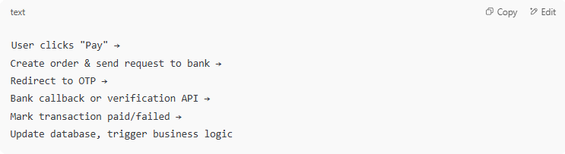

User clicks "Pay" →
Create order & send request to bank →
Redirect to OTP →
Bank callback or verification API →
Mark transaction paid/failed →
Update database, trigger business logic

